ABSTRACT
Online job sites have grown fast, letting companies find many applicants without much effort. Yet more people applying means it is harder to sort through resumes and pick strong contenders. Old-style tracking tools usually just scan for keywords when reviewing candidates. These systems miss deeper connections like related abilities or what words really mean in context. Because they do not understand nuance, good fits might get overlooked based on how someone wrote their experience. Small differences in phrasing or layout can cause qualified individuals to be ignored.
Built from the ground up, this tool brings together smart hiring tech powered by artificial intelligence. Instead of just matching keywords, it digs deeper using language models that grasp meaning beyond words. On top runs a full web setup - database, server, frontend - all tied together smoothly with backend logic. A separate brain written in Python handles the heavy thinking for smarter decisions. Recruiters find what they need by posting roles, reviewing people who apply, then narrowing down picks. Two numbers guide choices - one comes from classic search tricks, another shaped by machine insight. Applicants send in their work history, get matched to fitting jobs without shouting about "perfect fits." Hidden patterns help suggest where someone might land well, quietly nudging them toward better options. Edits flow back too, showing ways to rework resumes so they speak more clearly to machines and humans alike. Before talking to employers, users face practice prompts built on real job details, no generic quizzes. Everything splits into layers that grow easily, never forcing one piece to carry the whole weight.
Inside the setup lives a full path for handling resumes - breaking down PDFs, pulling out text, cleaning it up, then judging meaning. What the artificial brain does is compare applicant details to role needs, shaping useful context and fit ratings along the way. Trials showed something quiet but clear - the smart method of reading meaning lines up closer to real human judgment than just chasing keywords ever did.
Finding good hires moves faster now because the process works better for everyone involved. What happens when coding meets smart algorithms? A tool shaped by study, built to grow, solving hiring issues people face every day.

Chapter 1: Introduction
Nowadays, digital tools keep changing how companies hire people. Online job sites plus software that tracks applicants help speed things up. Posting jobs reaches more people than before. Getting tons of resumes is normal now. Sorting them by hand takes forever. Some good fits might slip through the cracks without anyone noticing. Too many applications can slow down decisions instead of helping.
Old hiring tools usually scan for certain words in resumes, matching them to job posts. Because these systems just count terms instead of grasping meaning, they miss subtle connections. Even if someone has useful background, slight wording differences can cause rejection. People who repeat phrases without real depth often rise higher by accident. Understanding grows harder when phrasing varies across industries or roles. Smart fixes must go beyond word matches to see true fit. Filters stuck on exact terms fail both workers and companies slowly. Real skill doesn’t always come with expected labels attached. Better approaches would notice patterns behind varied expressions. Today’s gaps show why change matters - quietly but deeply.
Something interesting is happening with machines that understand language. These tools now grasp meaning in messy, real-world text just like people do sometimes. Because of this shift, job-matching systems are starting to change how they work. Instead of only scanning for exact words, they begin to see context and fit. Machines assess resumes by judging substance rather than checking boxes. Fairness creeps into hiring when decisions rely less on luck or phrasing tricks. What used to be rigid filtering becomes something closer to thoughtful review.
Job hunters struggle just as much as hiring teams when it comes to finding the right roles, refining application documents, or getting ready for meetings with employers. Without solid direction, plenty of people send applications everywhere, which often leads to wasted effort and fewer positive outcomes. A single system could help both sides - making candidate review smoother for companies while offering smart tips and tailored support for those applying.
Facing these issues head-on, this effort introduces a smart hiring tool powered by artificial intelligence, blending a complete web setup with intelligent backend functions. Built on the MERN framework, it pulls in a separate AI module written in Python to study resumes and grasp meaning beyond keywords. Instead of relying only on exact matches, the method uses two scoring styles - one based on terms, another on context - offering clear results with better precision. On top of that, users gain access to tailored job alerts, tips for refining their resumes, and support getting ready for interviews, forming one unified response to today’s hiring demands.

1.1 Purpose / Motivation
Most times, old-school hiring tools miss what people can really do. Instead of seeing the full picture, they just hunt for keywords in resumes. Because of that, a lot of hidden talent slips through the cracks. Recruiters end up stuck with slow decisions, while good fits never get noticed. Meaningful connections between skills and jobs? Rarely spotted.
What also drives this effort is using progress in Artificial Intelligence, especially Large Language Models, to make hiring choices sharper. Through AI-powered understanding of meaning, the system works to assess applicants in ways that mirror how people would judge. Job hunters stand to gain too - with smarter job matches, guidance on strengthening resumes, even aids for getting ready to interview.
One goal here is connecting classroom ideas to actual use - building something tangible shows how old-school approaches can work alongside today’s AI tools. Because it blends both sides, the outcome stays clear in logic yet taps into strong machine-driven insights.
1.2 Objectives
The main objectives of this project are:
- A fresh start brings a full-stack job matching system built with MERN tools. Recruiters get one path, applicants another - both live in the same space. Code shapes each side, front to back, without skipping steps. One piece fits after another, quietly forming structure. Users move through it like walking into a room they know. Work happens behind the screen while faces stay calm up front. Building means choosing parts that hold weight later. Nothing shouts, everything connects.
- A fresh approach begins by blending keyword checks with smart analysis. Instead of just counting terms, meaning matters too. One part uses matchScore to track familiar words. Another leans on aiScore to grasp context. Together they form a balanced view. Not either-or but both working behind the scenes. The result? A closer look at what each resume really offers.
- A fresh start begins with building a small program in Python that reads resumes smartly. This tool digs into meaning by examining word patterns and context clues. Instead it suggests fitting roles using what it learns about skills and experience. The system works on its own once set up right. It pulls key details without needing extra help. Each step flows from one task to the next quietly.
- A system helps hiring teams sort applicants quickly by using several scoring factors at once. One after another, criteria shape how each person moves forward. Scoring combines feedback so decisions stay consistent across roles. Each check adds clarity without slowing things down.
- A system matches jobs to candidates using details from their resumes. Profile information helps shape each suggestion. What someone has done guides what they might see next. Past roles influence future options shown. Experience listed becomes part of how results form. Background data plays a role in sorting opportunities. Skills mentioned help determine possible fits.
- To integrate AI-powered resume improvement suggestions to help candidates enhance their profiles.
- A fresh take on practice interviews begins with smart prompts shaped by job type. One step ahead means answers get tailored through learning tech. Role-based scenarios pop up naturally when systems adapt. Each round shifts slightly, guided by what the position demands. Questions form based on real-world tasks people face there.
- Facing growth needs means parts must work alone or together without hassle. Communication stays locked down tight across user interface, server logic, AI tools - no exceptions. Each piece hooks into the next through clear paths, never tangled.
- A closer look at how keywords stack up against artificial intelligence when sorting through candidates. One method relies on preset terms, while the other learns patterns over time. Where keyword filters stop, smarter systems keep adapting. Some teams stick with rules they can see, others trust models that evolve behind the scenes. Each path handles volume differently under pressure.

Chapter 2: Literature Review
At first, computers sorting through job resumes used basic word counts, much like early hiring software. Tokenizing texts, stripping common words, then scoring key terms came before matching to job posts. Some researchers leaned on TF–IDF math paired with angle measurements between vectors - simple, clear, fast enough for mass filtering [1]. Because they worked well without heavy computing demands, many systems started using them quickly. Handling thousands of résumés felt manageable thanks to their straightforward design. Though earlier efforts used TF–IDF paired with simpler methods like k-nearest neighbors or logistic regression - and saw decent results on clean data - their success often fell apart when faced with different word choices, uneven resume layouts, or personal phrasing quirks, making them less reliable outside controlled settings.
Later work tackled those gaps by blending different word-matching techniques - like how often terms appear, alignment across parts of a resume, along with score adjustments based on relevance. Importance gets shifted toward key areas like job history, abilities, or academic background, mirroring how hiring managers actually assess applicants. Still, matches rely heavily on identical words showing up, missing deeper context behind phrases. Research shows people can lose points just for wording things differently, even if their expertise fits perfectly. Not only that, but systems relying on keywords can be tricked by piling in terms too heavily - making results look better than they really are [3]. Because of this, raw word matching shows clear weak spots when used alone.
Moving from old ways, NLP in hiring tools began focusing on meaning through patterns found in words. Instead of just matching keywords, approaches like LSA and later Word2Vec started mapping how close ideas are by positioning them in space. Because of this shift, systems could link phrases that meant similar things, offering glimpses into context. Even so, they struggled when faced with full sentences or distant connections across lengthy job applications.
One big leap here came when transformers and context-aware word forms appeared. Instead of just reading words one after another, systems like BERT began grasping meaning based on surrounding text. Because of this shift, machines started interpreting language more deeply. For hiring tasks, a tailored version called conSultantBERT uses twin networks to compare job profiles with applicant backgrounds. Even if resumes come in different shapes or languages, it still finds relevant matches. While some struggle with messy inputs, this approach handles variety better than older methods. On top of that, CareerBERT builds further by tracking how roles change across industries. Thanks to richer encodings, spotting portable abilities became easier over time. Performance gains show especially well when mapping complex professional paths. Each step forward tackles real-world gaps left behind earlier.
Looking deeper, some work checks how well small parts of text match, focusing on sentences or chunks instead of whole files. Rather than treat a resume and job post as one block, systems compare similar pieces like past roles, abilities, or tasks done. These split-up comparisons make it easier to see why a fit happens - or doesn’t - matching the way hiring people actually think. Evidence suggests judging line by line gives clearer answers than counting shared words alone, since exact overlaps stand out more when checked part by part [6].
Not every system handles job-matching the same way. Where older tools rely on exact word matches, newer ones actually grasp meaning through patterns. It turns out that spotting relevant talent isn’t about counting keywords but recognizing subtle connections in experience. Some methods miss qualified people simply because they phrase things differently. What works better is letting machines learn how words relate in real usage. Results across many tests show these smarter models rank stronger fits more reliably. The edge comes not from vocabulary size, but from reading between the lines. When a candidate's background doesn't match exactly yet still makes sense, context-driven networks see it - keyword scanners do not. Over time, evidence builds: matching should depend less on surface forms and more on what lies beneath.
Newer studies look at how Large Language Models fit into hiring processes. Instead of just matching keywords, these models think through each resume like a person might. They take in the whole document, spot hidden abilities, then lay out clear reasons why someone fits a role. Some setups use multiple AI parts working together - one reads the resume, another gives feedback, others help guide choices [7]. The goal is clearer decisions, showing how results are reached while keeping people involved in key moments.
Looking at how large language models handle assessment tasks reveals a mix of strengths and issues. Even though they grasp meaning and context well, results might shift based on how prompts are built or systems set up. Studies show steady approaches to prompting plus checks on outputs help keep things working right in actual applications [8]. The need for thoughtful pipeline construction comes through clearly when aiming for dependable behavior across runs.
At the same time, studies centered on job seekers have looked into how artificial intelligence can assist with polishing resumes and getting ready for interviews. Instead of generic edits, large language models create tailored changes based on specific roles, sharpening work history details while highlighting suitable abilities tied to position demands. Clear step-by-step methods for updating resumes tend to boost readability, flow, and fit with posted jobs - this often leads to stronger outcomes for applicants [9]. On a related note, tools powered by AI craft customized practice questions, both technical and situational, offering individuals focused rehearsal ahead of hiring evaluations.
Studies relying on surveys suggest recruiters now lean more toward tools powered by artificial intelligence. Not just any system, but ones giving background details instead of raw numbers. These tools build confidence because they show how decisions unfold step by step. Understanding why one applicant ranks higher helps hiring staff feel more at ease. The bigger picture? Clearer AI means better support - not full takeover - in today’s hiring workflows.
Even with progress, few controlled experiments test keyword scoring against semantic AI using the same setup. Many current tools stick to just one method or skip consistent testing rules. Without uniform comparisons, measuring how much better semantic models really are becomes difficult.
Looking at what has been missing in past work, this project uses a mix of methods - one based on keywords called matchScore, another powered by artificial intelligence known as aiScore - both built into one hiring tool. Instead of testing them separately, they run together using identical data and processes, allowing clear comparison. Running parallel tests brings clarity about how each method performs under the same conditions. Efficiency in hiring improves, yes - but more importantly, it reveals how well smart algorithms handle actual job-matching tasks outside theory. Real usage shapes understanding here, not assumptions.

Chapter 3: Methodology
3.1 Overview
This project builds an interview tool using old-school word matching along with smart language understanding powered by artificial intelligence. Instead of treating job application review as a separate step, it fits assessment tools into the full hiring path. So the software runs like actual workplace tech while making clear how standard methods stack up against newer ones. Each part grows easily, works independently when needed, stays uniform throughout, linking hands-on building with study goals from start to finish.

3.2 System Architecture
A fresh setup splits work across three levels: one part talks to users, another runs tasks behind the scene, while a separate smart helper handles thinking jobs. Users interact with screens shaped by React, seeing different views based on whether they hire people or apply for roles. On the flip side, server logic built in Node.js plus Express checks logins, posts openings, tracks submissions, and reaches into stored data when needed. That brain-like piece? It lives apart, coded in Python, pulling meaning from resumes, weighing fit through word patterns, then suggesting matches without human input. Each chunk works alone yet fits together like puzzle parts moving the whole thing forward.
One reason this works well is how it splits duties between parts of the system. Because of that setup, the AI part does not tie into core app functions directly. Changes in one area do not force changes elsewhere, making updates easier over time. Instead of everything bundled together, pieces grow or shrink based on need. The way things are divided matches what many teams now do when handling heavy computing jobs. Tasks like running models live apart from regular code, tucked into their own space. That split helps avoid clutter while keeping performance steady.

3.3 System Workflow
Starting at the login screen, recruiters kick things off by setting up new roles online with full details like duties, must-have abilities, and special conditions. A solid description becomes the baseline others are measured against later. People looking for work sign in separately, build personal pages, then send applications using resume files saved only as PDFs. Automation runs quietly behind each step, making sure hiring feels natural but moves fast.
After a resume arrives, the system kicks off an automated review process. Off it goes to the AI service, where analysis begins using smart algorithms. Then comes scoring - first by matching keywords, next through pattern recognition powered by machine learning. Both results land safely in storage, ready for access. They show up clearly on the screen recruiters use daily. From there, choices get narrowed down using filters tied to specific score types. Sorting happens smoothly, guided by what matters most to hiring teams. Actions taken upfront link directly to how data moves behind the scenes.

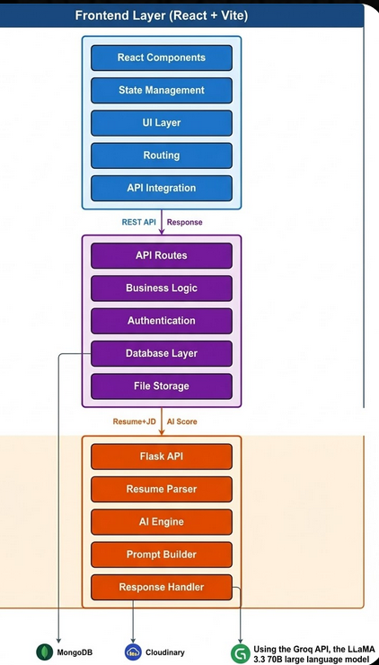

3.4 Resume Parsing and Preprocessing
One key part of the method involves turning messy resume files into clean, organized data computers can understand. When someone uploads a PDF resume, the system pulls out the words inside, saving details like job history, abilities, schooling, and past work. Because resumes come in many shapes and styles, cleaning them up helps keep everything uniform across inputs.
Starting fresh, the raw text gets stripped of odd symbols, extra gaps, and messy layout issues. Because of this cleanup, every resume looks more alike, which helps avoid skewed results later on. Into neat blocks it goes - experience here, skills there - shaping up each part so nothing feels lost. With everything lined up just right, machines scan them smoothly, whether hunting keywords or weighing fit through smarter analysis.
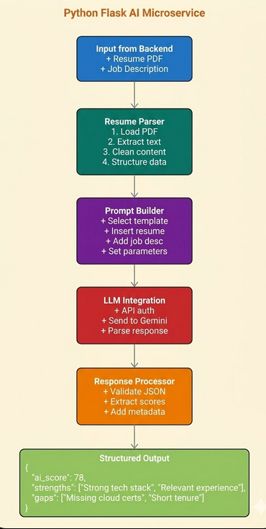
3.5 Keyword-Based Evaluation (matchScore)
A fresh look at how the system checks applicants begins with old-style word spotting. Think of it like classic hiring software - it hunts for certain phrases that match what a job needs. Instead of deep analysis, it lines up key points pulled from the role's outline against details listed in each resume. Matching happens when those required skills show up plainly in the applicant’s document.
Starting from how words line up, a number called matchScore shows how much the resume matches the job post. This value gets adjusted so it always fits within 0 to 100, making comparisons straightforward. Built on shared vocabulary alone, the approach runs fast - common across companies today. Yet meaning often slips through when phrases look different but relate closely in sense.

3.6 AI-Based Semantic Evaluation (aiScore)
Instead of just matching keywords, the system uses a smart model to grasp what both the resume and job post really mean. It looks at everything together - no piecemeal checks - to judge how well someone fits. Because it reads context, it can spot abilities that aren’t plainly listed. What matters is whether past work truly lines up with what the role needs.
A number called aiScore comes out of the machine, showing how well it grasps what a person might offer. Ranging from zero to one hundred, that figure gets adjusted so every result lines up neatly. Instead of just spitting out digits, the software offers reasons behind its rating, letting hiring staff see the logic at play. When resumes lack certain terms, this method still spots potential matches by reading between the lines.

3.7 Dual Scoring Framework
What stands out in the approach is how it uses two scoring systems at once - one built on keywords, the other powered by artificial intelligence. At every step, matchScore runs alongside aiScore for each applicant, both saved directly into the database. Recruiters gain the ability to view applicants through classic filters as well as modern algorithmic insights - side by side.
One score shows how well candidates fit on paper. Yet another tracks real-time performance clues. Together they form a base for deeper study into what works best. Matching results head-on reveals shifts in rank order. It highlights which details matter most across settings. Some methods favor tradition while others lean sharp edges of machine learning tools. A steady link forms where old habits meet fresh logic. Each setup speaks differently about value. Still both aim at clearer judgment.
3.8 AI-Assisted Features
Besides scanning resumes, the system uses smart tools to make things easier for users. Because it checks each resume closely, it can spot ways to improve how clear and well-organized they are. When needed, it offers tips so job seekers adjust their documents to better fit specific positions. As a result, people often build stronger applications without extra effort. Getting noticed by employers becomes more likely when these changes are made.
Interview prep comes built in, using your background and the job details to create tailored questions. Because it pulls from real role demands, practice feels more realistic. One part helps you get ready for both skill checks and conversation-style talks. Matching jobs to people happens through another layer, scanning resumes to find openings that fit. When suggestions line up with what someone has done, applying tends to go further.

3.9 Evaluation Approach
Looking at how the system performed meant checking candidate lists made by matchScore and aiScore through many job applications. One ranking came up differently than the other, so we looked closely at why context mattered more in some cases. Where keyword systems overlooked people, the AI method often found stronger fits without obvious resume matches. Decisions based purely on terms missed applicants who showed better long-term potential. Sometimes a lower-ranked name turned out to be the right hire after human review. What seemed like mismatches initially revealed gaps in traditional scoring.
This look at how things stack up showed what happens when semantic AI joins hiring tools, revealing gains that come from blending machine-driven review with long-standing methods
3.10 API Communication and Data Flow
Communication happens through RESTful APIs linking separate parts of the system. When users log in, check jobs, or send applications, the frontend talks to the backend. Each task flows across these connections without extra layers. Actions move step by step between interface and server.
Messages move between the system and the AI using clear structures, helping handle jobs like reading resumes and judging meaning. Data travels back and forth in set patterns, keeping things steady without slowdowns.
A connection built on APIs keeps things split up neatly, so parts of the system can grow or change without dragging each other down. When outside tools need to plug in later, the path stays clear and straightforward.

3.11 Database Design and Data Management
Running on MongoDB, the system keeps its information neatly stored. Different kinds of records find their place here - users sit alongside job listings. Applications flow in, saved just like any other entry. Even results made by artificial intelligence get filed away properly.
Profile info, job roles, plus what's on a resume make up user data. Descriptions of openings, needed abilities, along with who posted them form job listings. Links between people and positions show up in application history, also include ratings given during review.
A solid setup helps find info fast, keeps growth smooth at the same time. What backs it up? Steady handling of hiring details without hiccups along the way.

3.12 Security and Authentication
When someone logs in, they must provide trusted details before getting access. Once verified, a unique token gets created through JWT to keep things locked down. The system uses these tokens instead of constant re-login checks. Protection stays strong because each step follows strict identity rules.
Only certain people see specific parts of the system depending on their job. People hiring can reach tools others cannot. Job seekers get a separate view, kept apart by design. Actions that matter stay hidden from those who should not touch them.
When users access certain parts of an API, protection kicks in through layered checks that confirm identity before allowing entry. These built-in safeguards act like gates, verifying who someone is then deciding what they can touch. Security takes shape not just by locking doors but also by watching every move inside. Data stays safe because rules apply automatically each time a request passes through. System stability grows stronger when only approved actions proceed without interference.
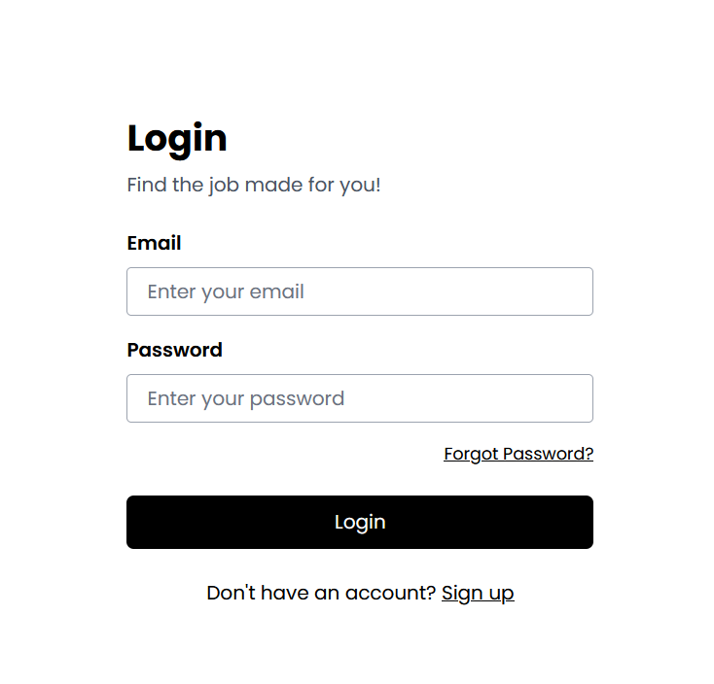

3.13 Tools and Technologies Used
Built with today’s web tools mixed with smart software tricks. React shapes the front part, making screens respond fast when users interact. Server tasks run on Node.js, tied together with Express for smooth data flow behind the scenes.
A choice has been made to store app information using MongoDB. Running on Python, the AI system pulls insights by connecting to Large Language Models through their interfaces.
From time to time, PDF parsers help pull data out of resumes. Meanwhile, frameworks handle how systems talk through APIs. Built this way, the whole setup grows easily, runs without hiccups, stays strong under load.

Chapter 4: Implementation

4.1 Overview of Implementation
Running behind this tool is a complete software setup tied to a smart mini-system fueled by artificial intelligence. Built to mirror actual hiring processes, it uses automated thinking for sorting resumes, rating applicants, one task flowing into the next. Instead of sticking to simple listings and follow-ups like older systems do, this one thinks ahead, adapts, responds. Decisions get sharper, work moves faster, all because learning machines help shape each step along the way.
Putting it all together involves three main parts: the frontend, the backend, because of the AI service. These pieces are built one at a time however connected using clear RESTful interfaces so information moves smoothly across them. What you see and click lives in the frontend since that's where people interact with the whole setup. All core decisions happen behind the scenes due to the backend handling rules, logins, along with data storage work. Heavy number crunching happens inside the AI part whenever resumes get broken down, meaning gets pulled out, while smart observations come out afterward.
Built in pieces, it grows easily, stays manageable, works many ways. Layer by layer, tasks stay apart, so heavier loads run smooth, updates come without tearing things down. An AI piece runs on its own, keeps the core app fast, never slows it during heavy thinking.

4.2 Backend Implementation
Running on Node.js with Express.js, the backend creates a steady space for server tasks to unfold smoothly. Because it handles core functions, every request gets sorted through rules that guide actions behind the scenes. When someone logs in, checks data, or sends input, steps follow one after another without pause. It connects what users see to stored information plus outside tools that add smart responses. Through quiet coordination, pieces link together - frontend talks, database listens, AI replies - all guided here.
One thing stands out in how the backend works - authentication through JSON Web Tokens keeps things locked down. Once someone signs in, a unique token gets created, riding along with each new request to confirm identity without storing session data. Because it relies on tokens, the system stays light and avoids server-side tracking. Permissions shift depending on whether you are labeled recruiter or applicant. That label decides what parts of the app you can touch. Recruiters gain tools to handle job listings and review applications. On the flip side, those applying for work get pathways only to submit forms and adjust personal details. Boundaries stay firm through role-driven checks woven into every layer.
Starting things off, the backend offers RESTful APIs handling key actions like signing up users, logging them in, creating jobs, fetching job details, sending applications, along with reviewing candidates. Communication flows through these endpoints, linking front and back systems so interactions stay fluid and updates happen instantly. What stands out is how neatly the routes and controllers are split into modules - code stays tidy, making later changes less messy.

Storing everything from user details to job listings, MongoDB serves as the main repository for system information along with results created by artificial intelligence. Connected through smart design, data pieces like applicants and jobs relate clearly within the setup. Take an application entry - it ties a person to one particular role while saving calculated ratings like matchScore plus aiScore. With links built right in, searching becomes faster, powering tools that sort or narrow down candidates smoothly. This way of organizing helps retrieval happen quickly without extra steps getting in the way.
Out there behind the scenes, the backend links up the AI piece without fuss. Once someone uploads a resume, it fires off the cleaned text plus the job details to the AI tool. Back comes a reply - packed with meaning-based ratings and suggestions - is tucked into storage. That data then flows where the user can see it. All of it stitches together old-school code and smart features like they were always meant to run side by side.
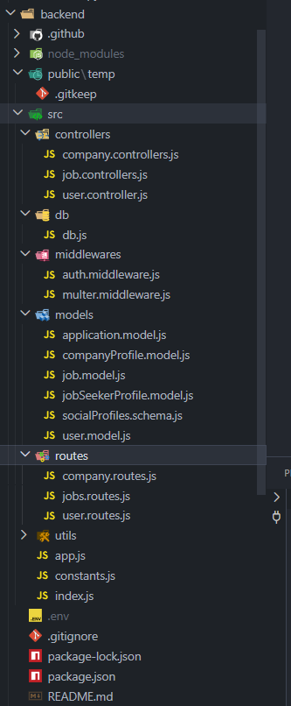

4.3 Frontend Implementation
React.js powers the front part of the system, creating an interface that reacts quickly to user actions. Built with separate pieces, each section can be used again elsewhere, making updates simpler over time. From the first click to the last step, everything flows smoothly for hiring staff and job seekers alike, guiding them through tasks without confusion. Navigation feels natural, interactions stay clear, features remain within reach. Structure supports function, design serves purpose quietly behind the scenes.
Applicants find their way around a setup built for creating profiles, adding resumes, plus looking through jobs while keeping tabs on where each application stands. A place waits where people add files - PDF only - and scan openings that match what they seek, then send interest without leaving the site. Hints appear now and then, shaped by patterns machines notice, nudging users toward sharper resumes or stronger answers before meetings. What shows up adapts quietly, feeding small improvements into how someone moves through searching, applying, preparing. Each step connects behind the scenes so nothing feels scattered or lost along the path forward.
Recruiters find tools like job postings, handling applicants, alongside ranking them right inside the dashboard. Each role shows every application at once, plus comparisons through keyword matches and AI-driven ratings. Sorting by different criteria unfolds possibilities - spotting strong fits becomes more natural. Seeing how AI reaches its conclusions adds clarity, shaping choices with clearer backing.
Communication between front and back happens via REST APIs, keeping data fresh on both ends at once. With React hooks doing the work, state stays under control - data flows smoothly, sessions persist, changes apply fast. Navigation stays locked down where needed, so only allowed users move forward. Clarity leads here: tangled steps get broken up, AI results come out plain to see.
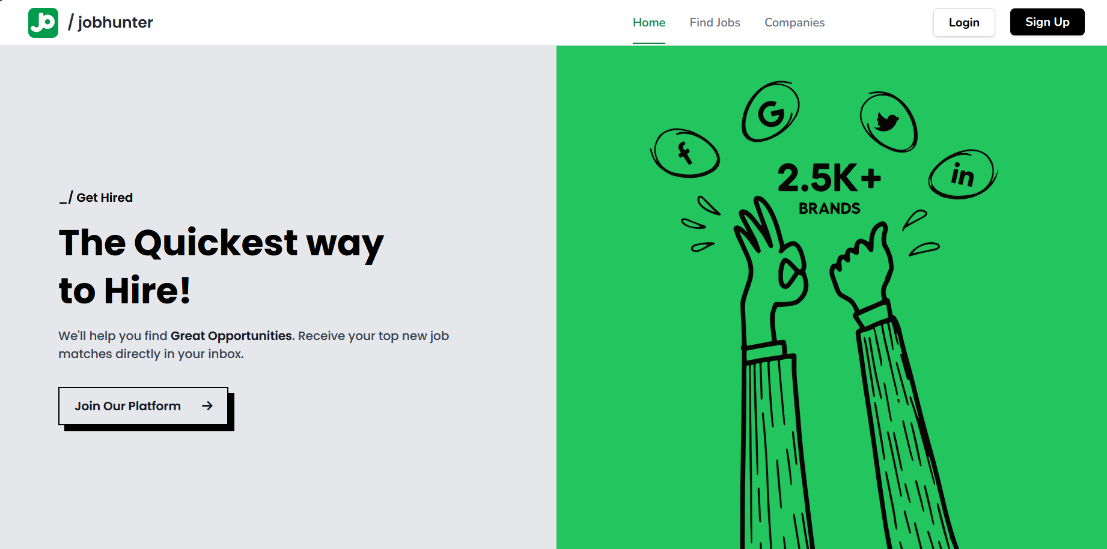

4.4 AI Service Implementation
Running on its own, the AI part uses Python as a standalone piece of the setup, built to grow and stay independent. It handles smart tasks like reading resumes, understanding meaning in text, matching patterns, while giving tailored suggestions based on data. Kept apart from the core app, it works without slowing anything else down. Heavy processing happens here so everything else runs smoothly.
When the system needs artificial intelligence functions, it contacts specific interfaces through its internal structure. Instead of running locally, these components manage operations like reviewing job summaries, improving those documents, then creating discussion prompts for hiring talks. To grasp meaning within written material more thoroughly, external language systems link up during analysis phases. Such connections allow nuanced interpretation beyond basic word matching routines.
Once the system gets a resume and job details, it breaks down the information through guided analysis. By looking at how ideas connect, the tool picks out matching abilities while forming a relevance rating called aiScore. Beyond just numbers, it gives clear reasons and helpful notes - making results easier to grasp and apply. From context clues to skill patterns, every output is built to clarify fit without confusion.
One way to look at it is how each part works on its own. When updates happen, they don’t drag the whole thing down. Scaling up only what's needed keeps things light. New models can slip into place when ready. Older parts keep running while new ones test out. Trying different methods feels less risky this way. Changes come through quietly, without breaking flow. Future tweaks fit in like spare keys. Each shift stays contained, never spilling over. What runs now doesn’t block what might run later.

4.5 Resume Parsing Pipeline
Starting off, the resume parsing pipeline takes messy document formats and turns them into clean, organized information. Because every person styles their resume differently - some with bold headers, others with odd sections - it has to handle chaos well. Instead it brings order, pulling key details like jobs, schools, and skills without missing a beat. Without such a system, comparing one applicant to another would be slow and full of errors. Even when pages look nothing alike, it finds what matters.
Out of the starting gate, a PDF gets cracked open to pull out just the words. From there, every bit inside - skills, jobs held, degrees earned, things built - is pulled free. Noise fades next, along with odd symbols and messy layout quirks. Without cleaning up first, mistakes might slip through later on.
Once cleaned up, the system scans the text to spot main parts of the resume. Because it groups these pieces in a set order, finding details later becomes straightforward. Since everything follows the same layout, checking one against another feels more reliable. Matching terms works better now, even when using smart algorithms, simply because the setup stays consistent.
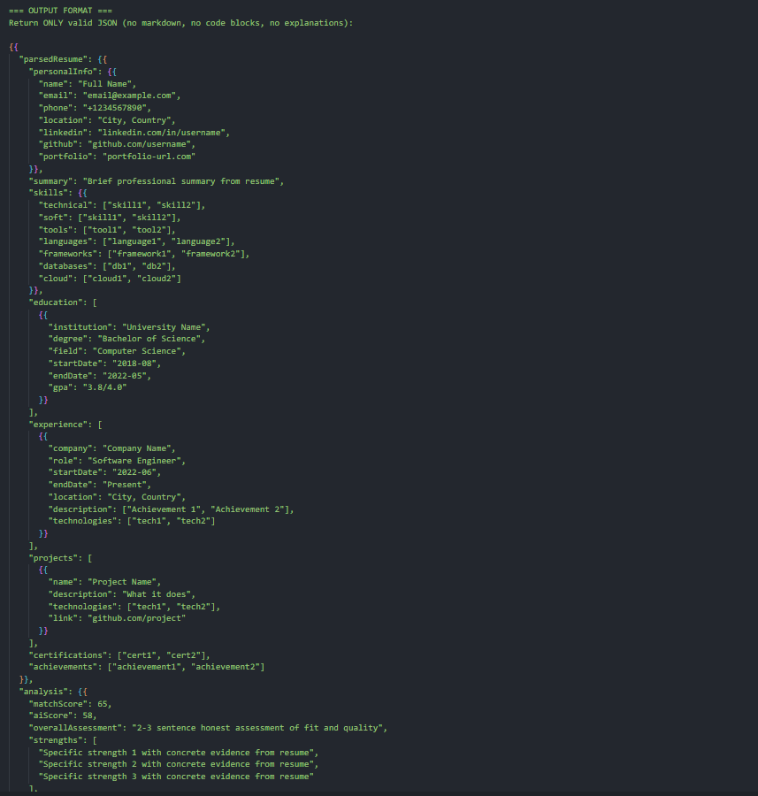
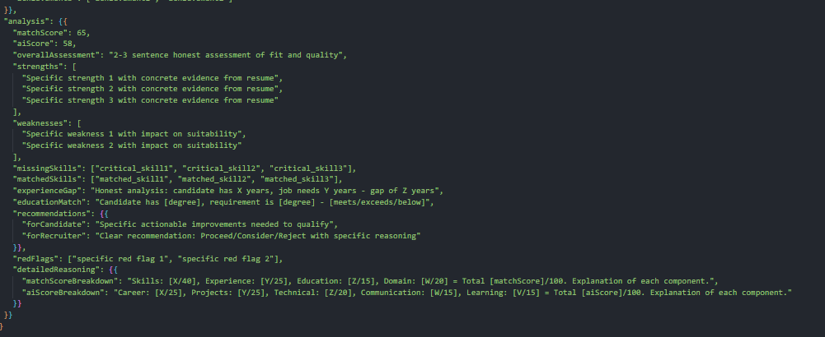

4.6 Keyword-Based Matching Implementation
A score pops up when resume words meet job post terms - this matchScore comes from counting overlaps directly. Think old-school tracking software: it checks how much wording lines up between applicant and role. Instead of deep analysis, it just tallies shared keywords plainly.
Pulling key terms and needed skills from the job description happens first, then those are lined up with what’s on the resume. Where they match shows how closely aligned the applicant is to the role. That alignment turns into a number after counting overlaps. Once adjusted, the result fits within 0 to 100 so it's easier to understand at a glance.
Starting off, this approach works well but comes with built-in flaws. Because of its design, it misses context and fails when terms shift slightly, often causing wrong results. Even so, researchers lean on it as a starting point to measure smarter, AI-driven techniques against.
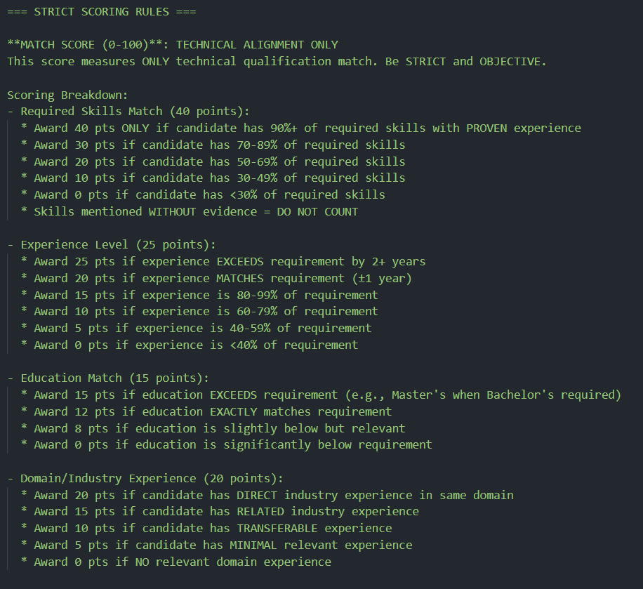

4.7 AI-Based Semantic Matching Implementation
Instead of just scanning for keywords, it digs into what words really mean within each sentence. A powerful language model helps decide how well a resume fits by reading between the lines. Meaning matters more than exact matches here. Context shapes every judgment call. This way, similarities emerge even when phrasing differs.
Out of the details in a resume and the job post, the model builds an aiScore by checking how well they fit together. Where someone has worked before gets weighed alongside what skills could carry over. Even if exact terms do not line up, strong fits still show through. Matching depth matters more than matching words.
Beyond scoring, the system offers clear breakdowns along with suggested steps. Recruiters see how decisions unfold because each rank comes with context. Accuracy climbs when judgments are backed by visible logic instead of guesswork.
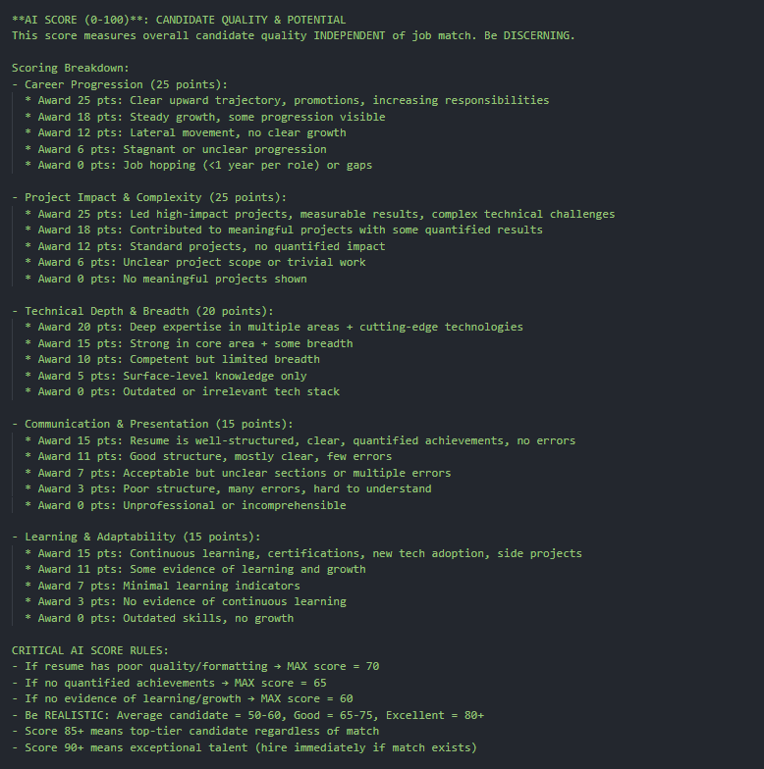

4.8 Experimental Setup
Testing how well the system works began with comparing many job ads against applicant resumes. From there, around 100 pairings of jobs and résumés formed the core sample. Some résumés followed standard layouts - others didn’t. Experience ranged widely across entries. Writing tone differed too, shifting from one example to the next. Because of these differences, results covered more ground than a uniform set might have.
Not one resume skipped a turn in either the keyword scanner or the AI judge. When the numbers lined up, mismatches showed where rankings drifted apart. What stood out got written down - how closely each system stuck to what mattered. Each step checked whether results matched what we’d actually hope to see.
4.9 System Performance and Observations
Testing happened across various scenarios to check speed, growth potential, and steady operation. Because services split into smaller parts, request management improved sharply - response delays during AI work dropped noticeably. Even when traffic spiked, the core systems held stable, managing many actions at once without slowing down; task evaluations by the AI moved forward smoothly each time.
Smooth movement across screens kept pace with live data changes, while clear menus guided each step forward. Even after adding smart tools, speed stayed steady - proof the setup handled growth without strain.
From start to finish, it held together well while moving through hiring tasks. Because parts worked separately yet connected smoothly, growth felt natural when putting it into actual use.

Chapter 5: Experimental Setup

5.1 Introduction
This section introduces the testing setup built to check how well the new AI-powered hiring tool works. Its main goal? To measure old-school keyword matching against smarter, meaning-aware analysis when sorting job applicants. One looks at surface words. The other digs into context. Results show which method ranks candidates more accurately. Testing happens under real-world conditions. Focus stays on fairness, speed, precision. Earlier systems often missed good fits. This approach aims to reduce those misses. Outcomes highlight differences in quality between both techniques.
Inside a working platform, applicants respond to live job ads while software ranks them, mirroring how hiring tools operate outside labs. Rather than examining code alone, researchers watch the entire process unfold, tracking decisions made by machines alongside overall system responses. What matters most: whether predictions match actual fit, understand context, support user needs, stay consistent with expert opinions. Results aim to show not just if it works, but how well it holds up when used for real.

5.2 Objectives of Experimentation
What happens next depends on goals spelled out ahead of time. These shape how each part gets tested. Each aim points the way during trials. Clear targets make it easier to check results. The process moves based on what needs measuring. Every test links back to one of these aims. Direction comes from knowing what to watch
- Finding out how well keywords spot job seekers who clearly have the right skills
- To analyze the performance of AI-based semantic evaluation in capturing contextual relevance and inferred skills
- To compare candidate rankings generated by matchScore and aiScore
- To assess the alignment of AI-based evaluation with expected human judgment
- To measure improvements in candidate filtering and shortlisting efficiency
Built to cover every angle, these goals check old methods alongside those powered by artificial intelligence.

5.3 Dataset Description
A fresh experiment runs on a set of about 100 resume-to-job matches pulled from real-world, everyday examples. Instead of narrowing down, it spans many fields - like coding tasks, number crunching jobs, and office-based work - to catch more ground across careers.
One thing you notice right off - every resume lays out a person's abilities, tech know-how, jobs they’ve held, schooling, plus projects they've tackled. Jumping into them, formats swing wildly, just like what happens in actual hiring piles. Some hit hard with clean sections and heavy keywords; others wander through story-like summaries, playing loose with design rules. No two look the same - the way they’re built, how words flow, even where headings sit - all over the map on purpose.
Each job posting has key details like needed abilities, daily tasks, plus what the role demands. Differences between postings mean testing covers a wider range of hiring cases.
From varied resumes to differing job posts, the mix puts the system through its paces. It faces uneven layouts, fields that shift, experience ranging wide. Structure bends, content changes - each piece tests adaptability. Formats twist, sectors differ, seniority spans push limits. Through it all, performance shows how well it keeps up.

5.4 Data Preprocessing
Starting fresh, every resume along with job details gets cleaned up first thing. Because these documents often lack order or carry messy layouts, fixing them early makes a big difference. Without that step, judging fit would be far less reliable.
The preprocessing pipeline includes:
- Pulling words out of resume files saved as PDFs
- Removal of special characters and formatting inconsistencies
- Conversion of text to lowercase for uniformity
- Removal of stop words to eliminate irrelevant information
- Tokenization and normalization of text
Starting fresh each time keeps things clear. With every step, the information becomes tidy, organized, ready - whether you're scanning for terms or using smart tools. Cleaning it up early cuts out distractions later on. Fewer errors show up when it's time to check how well things work.

5.5 Experimental Environment
Inside a tightly managed setup, everything runs using both full software layers alongside artificial intelligence functions. Each piece of the design links with others, acting like actual daily operations unfold.
The experimental environment includes:
- A window where people post jobs, then others send in their applications. One step leads to another, filling roles through shared effort. Tools meet needs without extra steps. Simple actions build connections over time
- Behind the scenes, a system manages incoming web calls while checking user access. It takes information, works through tasks step by step. One piece verifies logins before moving forward. Processing happens after confirmation arrives. Requests travel here first, not shown to users. This part connects pieces without drawing attention. Each job runs quietly in sequence
- A script in Python handles smart analysis by understanding meaning. One part checks context while another manages automated decisions. It runs small jobs using artificial intelligence methods. The system works on its own yet fits into larger setups. Tasks get done through learned patterns instead of fixed rules
- A place keeps CVs safe. Job ads live here too. Test scores get filed nearby. One setup holds it all together. Resumes sit with openings. Reviews join the mix later. Everything links through one structure. Files stay put unless moved. Data flows without breaks. Stored pieces connect when needed. Info waits until called
When things run as usual, the setup goes through checks using several touchpoints so results match how people actually use it. Built with separate small services working together, it manages heavy computing smoothly while keeping speed steady.

5.6 Evaluation Metrics
Finding out how well the system works happens through two main measures, tied to the way scores are handled across the project's setup

5.6.1 Match Score Keyword Based
A score like this shows where words on a resume line up with those in a job post. Where they meet gives you an idea - clear but basic - about fit based solely on what the role asks for.
5.6.2 AI Semantic Score
A fresh look at how well a resume fits a role begins with smart software reading between the lines. Instead of just matching keywords, it notices hidden links - like similar abilities from different jobs. What matters most is whether past work truly connects to what the position needs. Suitability emerges not from titles but from substance underneath.
These measurements work side by side - one built on keywords, one powered by artificial intelligence - to show starting points alongside deeper insights.

5.7 Experimental Procedure
A single path guides the experiment, built step by step to keep things steady and balanced during testing. Each phase unfolds like this:
- Stage 1: Job Posting Creation
Job ads get written by hiring staff who list exactly what they need. Sometimes specifics matter more than others when sorting applicants. Clear expectations help find the right fit without confusion later on.
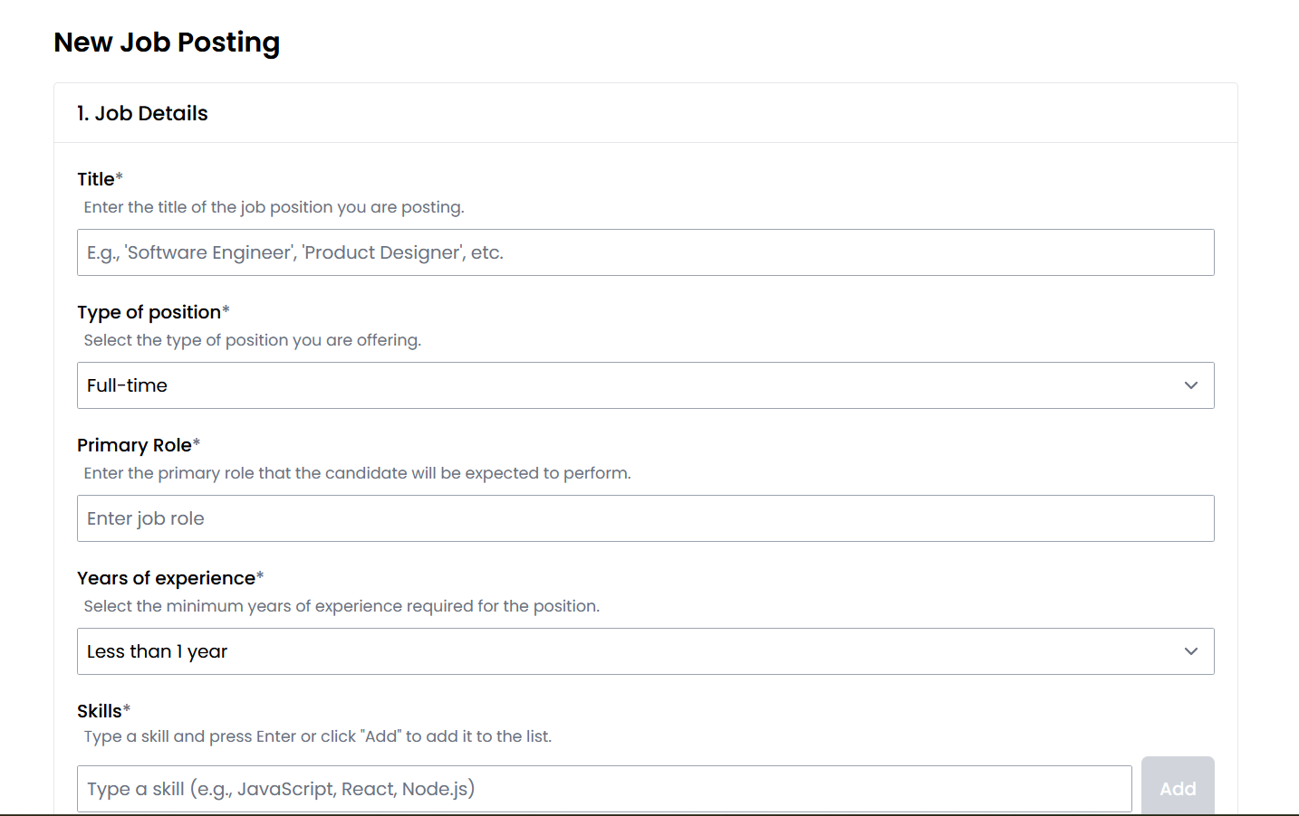
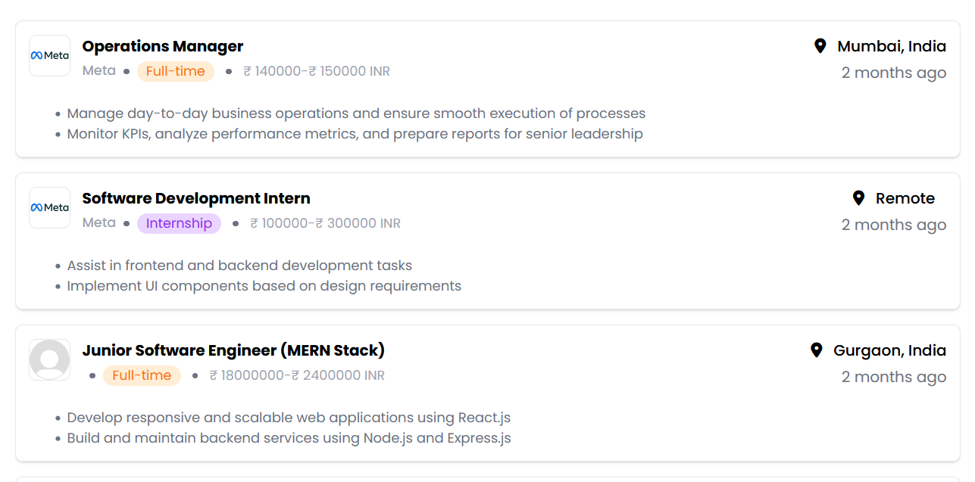
- Stage 2: Resume Submission
Filled forms arrive via the web screen. Pages of past jobs slide into view when people load them up there.
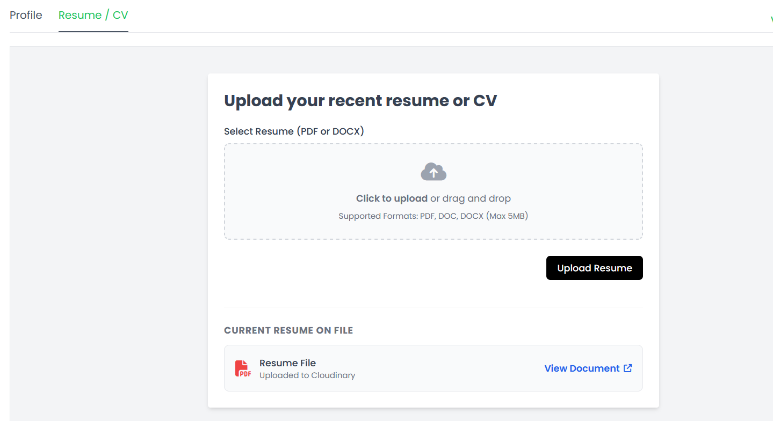

- Stage 3: Resume Processing
Parsed first, resumes get stripped down then rebuilt into clean data. Next comes sorting - every detail arranged for review later on. Structure matters once the noise is removed.
- Stage 4: Keyword-Based Evaluation
Finding matches? It checks how many keywords line up. Score shifts when words align more closely.
- Stage 5: AI-Based Evaluation
A single score emerges through pattern detection in meaning. This value forms when language gets broken into conceptual chunks.
- Stage 6: Candidate Ranking
Candidates get listed one by one, sorted by matchScore first - then again by aiScore. Order shifts depending on which score matters more each time.
- Stage 7: Comparative Analysis
Finding from one method sit beside those from the other, then get looked at closely. Differences begin to show only after a second glance.
Starting off different each time keeps things fair when using either way to check results.

5.8 Comparative Study Design
Ahead of everything, one test pits old-style word matching against smart meaning analysis. Though built differently, each approach runs on identical data points. Only then does fairness emerge - side by side, no favors.
The comparison focuses on:
- Differences in candidate ranking
- Ability to identify suitable candidates
- Sensitivity to resume structure and wording
- Alignment with expected recruiter decisions
From here, it becomes easier to see what each method does well - yet every one also has its weak spots.
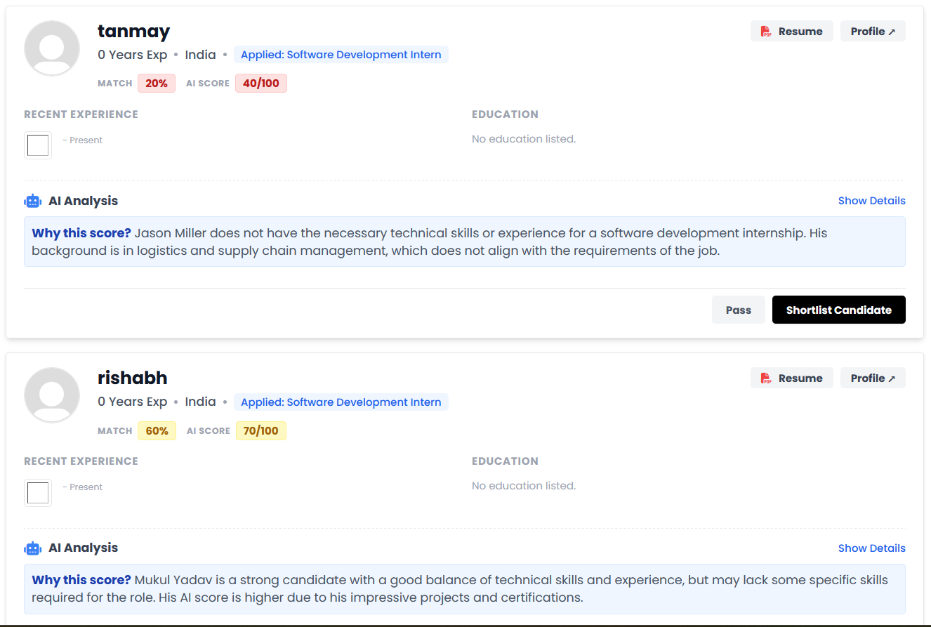

5.9 Observations During Experimentation
Several key observations were made during the experimental process:
- When resumes had precise words from job posts, keyword systems worked fine. Matching terms helped those approaches succeed. Where phrasing lined up closely, the technique showed strength. Exact overlaps made a difference for that strategy. If wording matched directly, results improved under that method
- Finding key applicants became possible through artificial intelligence tools, despite missing precise term alignments
- One way ranked people differently than the other. Sometimes high scorers dropped far down. At times, lower ones jumped ahead unexpectedly. Each method shifted positions in its own manner. Results didn’t match up closely at all
- Suitability of candidates became clearer through scores powered by artificial intelligence
- Finding sense in context opened doors to shifting abilities across tasks. What mattered was how ideas connected, not just what they said. Skills moved easily when the deeper layer clicked into place
Looking closer shows how AI scoring fits well within today’s hiring setups. Not every method works like this one does.

5.10 Performance Evaluation
A test looked at how well it worked, stayed steady, plus how easy it was to use. Findings showed picking applicants got better because meaning within context mattered more than matching keywords exactly.
Stability held firm through varied test runs. On one hand, the backend moved requests along without delay; at the same time, the AI portion kept crunching data without slowing things down. Up front, users saw changes instantly, found their way easily. Smoothness stayed consistent throughout.
Fewer steps now stand between recruiters and solid choices thanks to smoother handling of resumes. Clearer reasoning behind picks comes from smart tools working quietly beneath the surface.

5.11 Limitations of Experimental Setup
Even so, the test arrangement falls short in some ways
- A handful of entries sit here, tiny next to what live hiring systems handle. Size matters when matching actual job markets. This collection feels light on its feet, nowhere near the bulk of daily applicant flows elsewhere
- A single resume can shape how well a role gets judged. When details line up, decisions gain clarity. Job posts missing key points lead hiring off track. Clearer inputs mean fewer guesses later. Matching skill to task works better when both sides speak plainly. What matters shows through when paperwork does its job
- Depending on how questions are framed, results from AI models can shift. Structure matters just as much as wording when seeking answers. Sometimes small tweaks change outcomes entirely. How you ask influences what comes back. Details shape responses more than expected
- Testing with lots of users never happened
Fewer limits could open paths to better results - think bigger data pools, sharper cleaning methods, test runs outside labs. What holds back progress today might fuel smarter steps tomorrow, swapping old hurdles for fresh attempts where systems meet actual use.

Chapter 6: Comparative Study

6.1 Introduction
This section dives into how the new AI-driven hiring and job suggestion tool stacks up against current methods. A close look reveals differences through real testing across precision, speed, growth potential, and everyday usefulness. What stands out comes from side-by-side observation under similar conditions. Performance gaps appear when matching old systems to this updated design. Each method shows unique traits when handling large volumes of applicants. Results come from repeated trials focused on actual deployment scenarios. One approach moves faster while another holds more data without slowing down. Where older models struggle, the fresh system adapts quickly. Real-world demands shape every part of the comparison.
A closer look unfolds through two main angles. One angle weighs method against method inside the system - keywords versus artificial intelligence scoring. Outside that frame, another view lines up the system beside older hiring paths, legacy tracking tools relying on keywords, along with newer AI-powered hiring tech. Layering both views builds a full picture - not just how it works, but where it moves further than what came before.
What drives this chapter isn’t just showing where the new method works well - instead, it looks hard at where it falls short when stacked against older ones. Balance matters here, because real insight comes from honest review, not one-sided praise.

6.2 Comparison with Traditional Recruitment Systems
Recruiters often sift through resumes by hand, using personal know-how to spot potential hires. Human insight can help grasp a candidate’s background more fully. Yet things get tricky when hundreds of applicants apply at once. Judgment alone tends to slow everything down under heavy loads. Personal bias sometimes slips in without anyone noticing. Experience guides decisions, but it does not scale well. When piles grow taller, details fall through gaps.
A single job can attract piles of resumes, demanding long hours just to sort through them by hand. Because people handle the task, fatigue sets in - that slows things down even more. Hundreds might apply, yet each one needs close attention, creating a bottleneck right at the start. Mistakes creep in when eyes glaze over similar CVs day after day. What seems like careful review could actually favor certain names, schools, or backgrounds without anyone realizing. Patterns form unconsciously, nudging some applicants aside while lifting others up. Fairness slips when judgment leans on gut feelings instead of clear matches.
Instead of manual checks, this setup handles resume sorting through smart algorithms. Because it runs on its own, reviewing applicants takes much less time while staying uniform for everyone. With meaning-aware tech built in, it grasps each person's background more deeply than just spotting keywords.
One big plus of this setup? It grows easily when needed. When old hiring ways choke on too many applications, the automatic tool keeps going - handling dozens of resumes at once without slowing down. Perfect timing, really, since online job sites now pull in stacks of candidates every single day.
From start to finish, this new setup tackles core flaws in old hiring ways - speed gets a boost, unfair leans fade, while checking more applicants becomes doable.

6.3 Comparison with Keyword-Based Applicant Tracking Systems (ATS)
Even though sorting resumes by hand takes forever, computers now handle it faster. Still, many of these systems just hunt for specific words instead of truly understanding skills. That means good fits might get missed without anyone realizing why.
Resumes often get scanned by software hunting for certain words tied to a job posting. Though fast, these tools struggle to grasp what those words really mean together. Someone might explain their experience differently - using synonyms or varied phrasing - and still know exactly how to do the work. Yet the system could pass them over without a second look.
What often happens with keyword-driven applicant systems is they get tricked by repeated terms. Resumes packed with the same words over and over tend to rank higher, even when skills don’t match real expertise. When that occurs, the whole scoring method loses trustworthiness. Poor hires might follow simply because the system favored repetition over substance.
A new approach tackles these gaps using artificial intelligence to assess meaning, along with checking keywords. Though scanning for terms stays in place to keep results clear and comparable, the smart layer digs further into each applicant's background. Because it looks at how abilities are described, what kind of work history matters most shows up more clearly. Where someone gained their expertise begins to shape the picture just as much as the skills listed. The whole fit with the role comes through in ways simple word counts miss.
This way of combining methods gets better results when judging job applicants. Instead of just hunting for keywords like old systems do, it finds suitable people through deeper understanding. Because of that flexibility, it handles many kinds of resumes without struggling.

6.4 Comparison with AI-Based Recruitment Systems
Now machines can learn from data, helping sort job applicants faster than before. Because they read language like humans do, these tools spot trends in who gets hired across thousands of records.
Even though some AI tools bring strong features, they sometimes struggle with being clear about how things work. Because many of these models hide their inner process, hiring staff find it hard to follow the reasoning behind choices. When people cannot see how results come about, confidence dips - slowing real-world use along the way.
Fresh off the press, some hiring tools powered by artificial intelligence need heaps of example data plus serious computing muscle - costing a lot just to set up and keep running. On top of that, they often stumble when connecting with complete software systems, leaving teams juggling disjointed steps.
One way this setup stands out is how it mixes smart tools with real-world usability. Rather than going all-in on heavy algorithms, it pulls in Large Language Models using API links - so understanding meaning becomes easier without bulky training setups. What helps? It skips the complicated backend demands while still getting strong results.
Now here's a clearer version with varied structure: Seeing both keyword matches and AI ratings helps hiring staff understand each choice better. Because two kinds of scores appear side by side, picking candidates feels less uncertain. When people can check different outcomes at once, confidence in the tool grows naturally. Decisions gain clarity when numbers come from separate methods yet point together.
What sets this apart from current AI tools is how easily people can understand it, work with it, then bring it into hiring workflows. Instead of complex models, there's clarity - built right in. Some systems hide their logic; this one shows its reasoning without extra steps. Working across platforms feels smoother too, since pieces fit together by design rather than force.

6.5 Internal Comparison: Keyword-Based vs AI-Based Evaluation
One key part of the work looks at how keyword-driven checks stack up against those guided by artificial intelligence, both running under one setup. Seeing them side by side reveals what each method handles well - and where it falls short.
Simple words make keyword checks quick to run. Because they just line up resume terms with job posts. Yet speed comes at a cost - deeper connections between meanings slip through. Context gets lost when only exact matches count.
Still, AI-driven review uses smart text systems to study every part of a resume alongside job needs. Because it looks at how past roles are described, whether projects match the position, and what abilities can be guessed, the process digs deeper into fit.
Accuracy leans higher with AI-driven assessment compared to old-style keyword checks, matching human decisions more closely. Though counting keywords can set a starting point, real hiring situations involve too many layers for such rigid rules to handle well.
What stands out is how outdated word-by-word checks now seem, given the rise of smarter tools built to grasp meaning in conversation. A shift feels inevitable once you see machines catching context, nuance, even intent - something rigid formulas simply miss.

6.6 Hybrid Approach Advantage
A fresh angle comes through when the system mixes keyword checks with artificial intelligence grading. Where one method slows down, the other picks up speed. Built-in balance keeps weak spots from taking over. Each part feeds into the other without handing control to just one.
Starting with how it works, the hybrid approach lets hiring teams pick one scoring system or mix both for fairer judgments. Depending on the job, some positions might need stricter checks while others benefit from looser standards - this setup adjusts easily. Not every role fits the same mold, so having options helps match evaluations to actual needs.
Blending these two methods lets the system walk a fine line - clear explanations on one side, smart processing on the other. What keyword-driven results bring is openness, simplicity you can follow step by step. Meanwhile, those powered by artificial intelligence dig further, uncovering patterns missed at first glance, lifting precision without noise.
Trust grows when users see consistent outcomes, because recruiters check findings across methods, building belief in what the tool suggests. What stands out is how usable this setup feels, especially next to tools locked into just one way of judging fit.

Chapter 7: Results and Analysis

7.1 Introduction
This section dives into how well the new smart hiring tool works after being tested. What stands out most is its two-part scoring method, combining old-school keyword checks with smarter AI-driven meaning analysis. One part relies on exact word matches, while the other interprets context like a human might. Testing showed both pieces contribute differently but equally to better candidate-job alignment. Results were measured carefully across multiple real-world scenarios. Instead of just counting terms, the system grasps intent behind job descriptions and resumes. Performance improved especially in roles where wording varies widely. Accuracy jumped when understanding synonyms or related skills mattered more than literal phrases. Surprisingly, some mismatches by keywords alone turned out to be strong fits upon deeper review. Because of this blend, fewer good applicants slipped through cracks. The numbers back it up - better precision without losing relevant options. Each test run confirmed that mixing rule-based logic with intelligent inference lifts overall quality.
From different angles the findings unfold - through scores, rankings, context fit, human-like decisions, and speed. Each angle shows what one approach can do alone, while also revealing how machines add value when they work alongside people.

7.2 Experimental Outcome Overview
Testing happened across around 100 pairings of resumes and jobs, covering fields like coding, data work, and business positions. One by one, every applicant got reviewed through keyword checks along with artificial intelligence methods, producing separate ratings each time - one called matchScore, another named aiScore.
One system leaned on keywords. Yet the other dug into meaning, spotting links and hidden skills. Differences stood out clearly across outcomes. That gap suggested each method weighs suitability in its own way. MatchScore stuck close to what was written. AiScore reached further, reading between lines. Outcomes were not alike. Each one measured something separate. What matched exactly mattered here. There, it was about deeper connections. Clear contrasts emerged. Two paths, distinct views.
A closer look shows keyword checks alone can miss key details or give false impressions. On the flip side, using AI to score candidates often captures a fuller picture of their background.

7.3 Score Distribution Analysis
Looking closely at how scores spread out reveals clear contrasts when comparing keyword-driven analysis with systems powered by artificial intelligence.
Keyword-Based Score Distribution
●﻿﻿﻿﻿﻿Scores tend to be highly dependent on exact keyword presence
Candidates who repeat keywords tend to get higher scores by default
●﻿﻿﻿﻿﻿Distribution is skewed toward candidates with optimized resumes
AI-Based Score Distribution
Fairer results show up across the board now. Distribution spreads out instead of clustering. Balance shifts toward the middle ground. Numbers settle into a steadier pattern. Outcomes feel less lopsided than before
●﻿﻿﻿﻿﻿Reflect overall relevance rather than keyword frequency
●﻿﻿﻿﻿﻿Capture nuanced differences between candidate profiles
A closer look showed AI-driven ratings changed gradually from one applicant to the next, suggesting a steadier hand in judgment - unlike the jagged jumps typical of systems relying only on keywords.

7.4 Comparative Analysis of matchScore vs aiScore
When you look at how matchScore works next to aiScore, the way they judge things feels worlds apart:

Aspect | matchScore | aiScore
Basis | Keyword overlap | Semantic understanding
Sensitivity | High to exact matches | High to contextual meaning
Robustness | Low | High
Interpretability | High | Moderate
Accuracy | Limited | Improved

When resumes stick closely to job ad words, keyword methods work fine. Yet performance drops if applicants describe abilities differently. Sometimes skill hints appear without exact matches showing up. Matching suffers when wording shifts even slightly.
A fresh look at resumes comes from AI, which weighs job history, how projects match the role, along with how skills fit. Better judgments emerge when details matter more than checklists.

7.5 Ranking Behavior Analysis
One thing stood out in hiring tools - how candidates get ranked matters a lot. Results showed this clearly when tested under different conditions
One thing shifted big time when aiScore took over from matchScore - around two out of three candidate positions ended up way different. Not a small bump either, but a clear jump or drop in where they stood overall
Often, those once placed below because of keyword matches rose up when context mattered more
A few top spots vanished overnight when rankings shifted underfoot. Experience gaps showed up loud and clear despite strong keywords. Those who ranked high before now find themselves lower down. Real know-how started weighing more than word matches alone. Algorithms began favoring depth over surface signals. Without proof of practice, positions slipped quietly
A closer look shows keyword sorting might miss how well applicants actually fit. Instead, artificial intelligence arranges them in a way that feels truer to real ability.
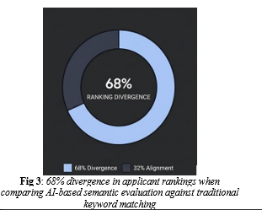
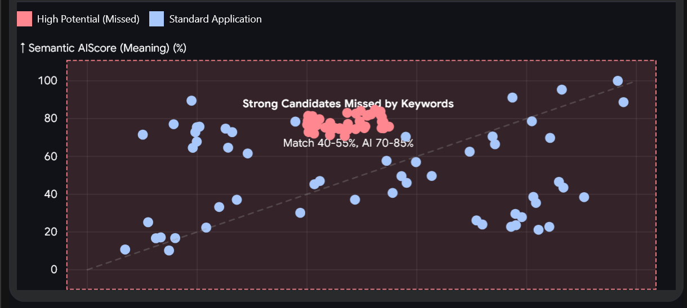

7.6 Detailed Case Analysis
A closer look at a few chosen examples revealed more detail:

Case A: Keyword Optimization without Relevance
Starting off strong didn’t help those who stuffed their resumes with the same words over and over - matchScores rose, yet aiScores dropped fast. Because real depth was missing, the system saw through it, pushing them further down the list.

Case B: Contextual Strength without Keyword Match
Out of nowhere, people who had deep background knowledge but used varied terms ended up with low matchScores yet surprisingly high aiScores. It turns out artificial intelligence can spot similar abilities even when words differ across job descriptions..

Case C: Well-Aligned Candidates
Sure thing worked out for applicants who matched terms while fitting the context - both scoring styles showed similar results. The pattern held across evaluations, suggesting the approach holds up under different checks.

Case D: Ambiguous Profiles
Finding subtle distinctions sometimes came down to how AI weighed context, when keywords alone couldn’t separate applicants.

7.7 Alignment with Human Judgment
What stood out most during testing? Watching how closely the machine's choices matched up against what people thought. Outcomes showed a clear picture emerging when those two were placed side by side
Most times, computer judgments matched people's opinions - about three out of four. Sometimes machines saw things similarly to how humans did. Roughly seven in ten decisions lined up between artificial systems and real individuals. In many situations, automated scores reflected what reviewers thought. Close to three-quarters showed agreement between algorithm results and personal ratings
Without grasping context, keyword-only ranking systems tend to drift off track. What hides behind words often gets missed when only matching terms. Matching phrases alone fails when meaning shifts subtly. Context gaps show up clearly in how results line up. Meaning matters more than exact matches ever can
●﻿﻿﻿﻿﻿Recruiters preferred AI-generated insights as they provided explanations and reasoning
Beyond just theory, these tools show how machines can back up hiring choices with data. What stands out is their role in shaping real-world job decisions through smart support.

7.8 Impact on Recruitment Decision-Making
The integration of AI significantly enhanced recruitment workflows:
●﻿﻿﻿﻿﻿Reduced manual screening time
●﻿﻿﻿﻿﻿Improved quality of shortlisted candidates
●﻿﻿﻿﻿﻿Provided actionable insights rather than just scores
●﻿﻿﻿﻿﻿Enabled better comparison between candidates
What stood out was how the dual-scoring method made things clearer, so recruiters could see results from keyword checks along with meaning-based analysis..

7.9 Statistical Observations
Here’s what happened when we ran the tests:
●﻿﻿﻿﻿﻿~68% average ranking deviation between keyword and AI-based methods
●﻿﻿﻿﻿﻿~72% recruiter preference for AI-based ranking
Keyword scores swing more than those given by AI. Sometimes they jump higher, sometimes drop lower - less consistent overall
●﻿﻿﻿﻿﻿Improved consistency in AI-based evaluation across different profiles
From these findings, it’s clear that reading between the lines gives hiring tools an edge. The way meaning is pulled from words shows stronger results than older methods. When context shapes decisions, outcomes shift noticeably. Meaning-focused checks tend to outperform basic keyword matching. What lies beneath word choice matters more than surface traits.

7.10 Limitations of Analysis
Few downsides remain, even with solid outcomes
A handful of data points make up the collection, nothing like what big operations usually handle
●﻿﻿﻿﻿﻿AI model performance depends on quality of input text
Few differences in resumes can shift outcomes now and then
●﻿﻿﻿﻿﻿Lack of longitudinal testing with real recruiters
Fixing these gaps points toward where work still needs doing.

7.11 Summary and Insights
What stands out in the findings is how much better AI-driven meaning checks are compared to old-style word-by-word searches. Even though scanning for keywords can help sort through applicants at first, it falls short when judging them properly.
The AI method makes things better
●﻿﻿﻿﻿﻿Contextual understanding
●﻿﻿﻿﻿﻿Candidate ranking accuracy
Matches Human Feedback
●﻿﻿﻿﻿﻿Recruitment efficiency
A fresh take on scoring splits the difference - clarity meets smarts in a setup that works beyond the lab. Where understanding matters just as much as performance, this approach holds up under actual conditions.

